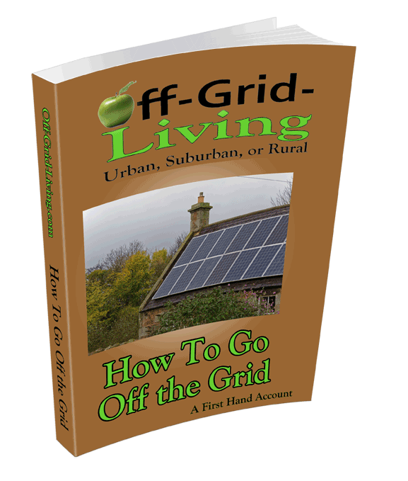
Lesson #2 …
Mindset

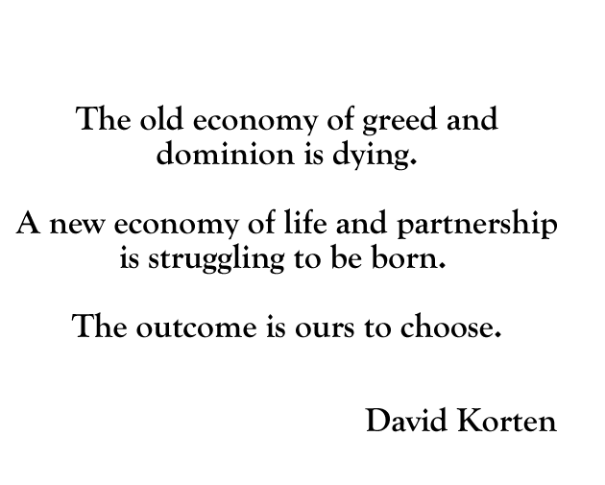
Hi, this is David Sieg from Off-Grid-living.com This video course is all about finding a measure of freedom in an increasingly unfree world. Without a doubt, the cost of food and energy in the coming years is going to reach unheard of proportions. This is simply a fact. If you didn’t believe it yourself, you wouldn’t be reading these words. This course isn’t about “causes” or “failures,” in the political system, we heard enough about them. This course is about SOLUTIONS.
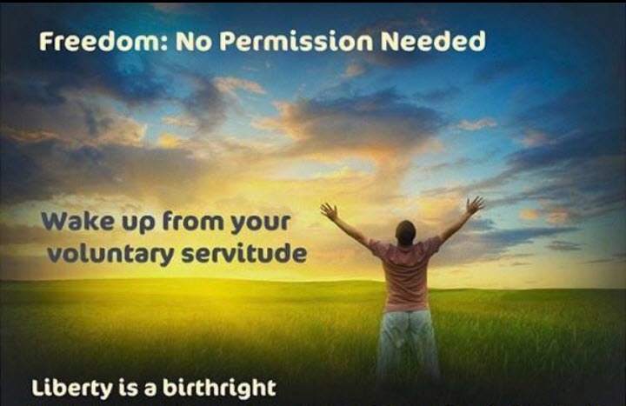
You can expect this course to give you the information you need, without a bunch of fluff or political BS surrounding it. In order to survive and thrive, at its most basic, you’ll need food, fuel, and shelter. That’s where this course will come in. In short, this course will give you the necessary knowledge and plans to get the job done. If you need more in-depth information regarding any aspect, We’ll have a community here to help you.
But it will be up to you to act on the advice given. Naturally, not all solutions won’t work for everyone but there will be enough solutions in the coming lessons to radically affect every aspect of your life, and change the way you look at life forever.
Can you really go off the grid? Come on…give me a break.
I’m perfectly serious. You CAN get go off the grid. It’s even affordable. It’s more affordable than the life you’re living now. I’m even going to show you a way, to get the government (Coming in the next lesson) and utilities to help with the cost.
But let’s start with an definition of the word itself. “Going off the grid” in the context of this video course, doesn’t necessarily mean disappearing into the wilderness, or becoming invisible. Although this course will put you well on your way to doing both.
What it means instead is unplugging and disconnecting from modern life in a way that enhances your basic lifestyle and freedom. It means rearranging your life in such a way that your life works for you, instead of you spending your life working for someone else. It means thinking of money as a tool, instead of as a goal.
It doesn’t necessarily mean giving up the parts of urban/suburban you like, it means getting rid of the parts that aren’t serving you and your new lifestyle.
Also, have you considered that “going off the grid” puts you square in the cross-hairs of officials who see any alternate lifestyle as a threat. Keep in mind, they want you to conform so they can continue to profit from you. Any deviation from that pattern draws attention.
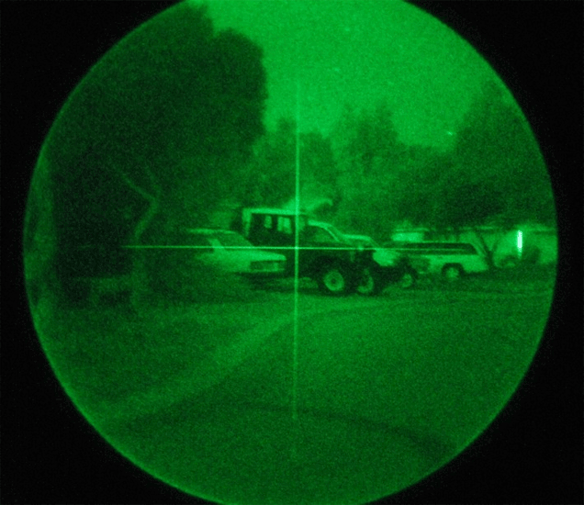
Instead, it’s much better to be a chameleon. To blend into your surroundings so that they never even know you’re there. And you do that by becoming indistinguishable from the faceless gray mass of humanity.
Let me give you an example: If you go completely solar and cut off your utilities because you no longer need them, that will draw attention from the Powers That Be. Why? Because you’re no longer paying into the forced economic system. That will invite them into your life. If you’re a hammer, everything looks like a nail.
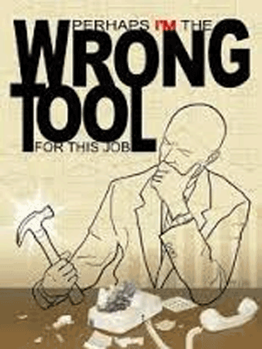

If you’re living in a urban/suburban area, it’s better to leave them hooked up, but reduced in such a way as it is no longer a burden in your life. Pay the absolute minimum instead. Not because you have to, but because it benefits you to do so. This accomplishes two things:
- It doesn’t make you stand out in any way.
- You can now use the grid-tie power system as a back-up, not the other way around.
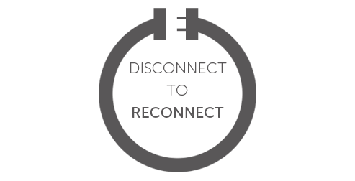
There are lots of reasons why this subject has come to the forefront of many people’s mind recently…
- Many people no longer trust the government to do what’s best for them.
- Everyone is seeing the cost of gas, food, housing, and utilities rise WAY beyond normal.
- Many people are aware of global warming and want to do something positive to help the environment.
- Forward thinking people (like yourself) are already putting into place back-up systems “just in case.”
First off, I’m not one who thinks that societal breakdown is coming. I don’t see the complete and total breakdown of our social fabric as some do. Nor am I prepper. (but it is only smart to have a months’ worth of food set by.) That said, I don’t see chaos, I see rebirth. But that doesn’t mean not to be smart.
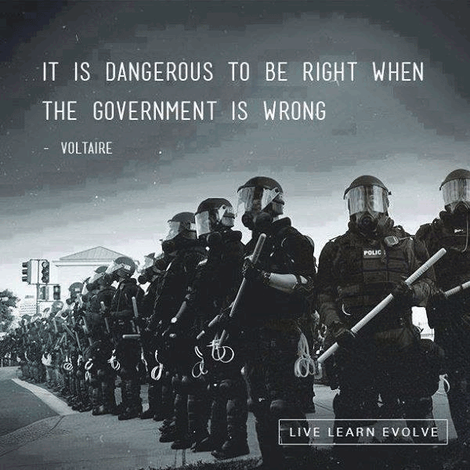
Some people will be better off than others. (Like you, if you follow what is outlined in this course) But that has always been, and always will be the case. This isn’t a time for despair; it is time to act.
Here are the top ten reasons why you should start going off the grid now.
- You will save hundreds of dollars a month, and thousands of dollars a year. Your utilities are only going to go higher. They are already in the $500 a month range for most of you. In the last year or two you’ve seen them double. Expect them to double again. Can you really afford to pay $1,000 a month for basic utilities? (I’m going to show you everything you need to know everything you need to know to all but eliminate your utility bill)
- You’ll be able to help the environment. Eliminating your dependence on the failed energy policies of the past will go a long way to cleaning up the mess we’ve made.
- You’ll be able to cut the power companies completely out of your life if you want. Or better yet, have them PAY YOU. It’s possible and it’s called “net metering.” This is a situation where you’re producing more power than you’re consuming and the utility companies will pay you for it.
- Cheap “anything” is a thing of the past. I think even the dimmest of bulbs can see that at this point, we are looking at an altered future, no matter what. Fossil fuels costs will continue to climb. This is going to happen whether you’re prepared for it or not. It is simple economics. How prepared you are for that eventuality is going to be what will lessen the impact. (I’ll have another course devoted to methods and way to grow and create your own fuel)
- Basic services we take for granted are going to become unrealistic. Don’t think so? Remember when health care was affordable? As of now, in the USA, there is not a single institution, be it education, social security, banking, insurance, criminal justice, transportation, or any other, that isn’t broken. As I write this (2016) it doesn’t look like there is any intention in Washington of fixing the infrastructure. That means, it is going to continue to go down. Which leaves you with a choice: Wring your hands and hope for the best, or get pro-active and fend for yourself.
- Heating your home in the winter/cooling your home in the summer is going to require new solutions. These are absolutely vital areas to consider in your life RIGHT NOW. If you live in the Northeast, you know how deadly the cold is. The same if you live in the Southwest. Heat can also kill you. (Part 2 of this course will be devoted to creating cheap, affordable, devices that can do both at a fraction of the cost.)
- Urban and suburban life as we know will undergo DRASTIC change. But it isn’t change which hasn’t ever been accomplished before. In Europe this has already taken place and we have their years of experience to fall back on. (In the coming chapters I’m going to be exploring many of the option that have stood the test of time and have found to work)
- No matter what, our lifestyle is going to change in the coming years. This doesn’t have to be a “bad thing.” In the coming months when you find you are making a consistent effort, little by little, to solve these problems, and seeing steady savings because of them, you’ll wonder what the fuss was all about.
- You can have a lot of fun building your own lifestyle systems.
This doesn’t have to be a drag. By doing this in small weekly chunks, you can get the whole family involved. By working together you’ll build a closer, stronger, family unit.
- By adopting these Concepts now, you’ll be years ahead of your neighbors, and ready to deal with the coming problems. How you do swallow a concept this large? One small bite at a time. That’s what we’ll be doing in the coming months, is biting into one small chuck of your lifestyle at a time, solving it, and moving on to the next. The advantage to doing things this way is before you know it, major aspects of the problem are solved.
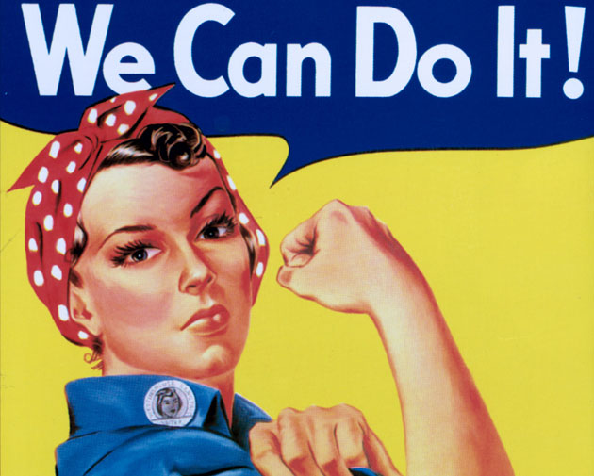

What You Can Do Starting Today

- Start by taking stock of where you expend the most energy in your lifestyle. What part of your life is causing you the most “pain.” Is it heating and cooling? Is it transportation? Is it your mortgage? Not making enough money? Zero in on solving what problem will make the biggest difference in your life.
- How aware is your family about the coming changes? The time to start educating them is now. These changes are going to impact their lives. The sooner they get used to idea, the less effect it is going to have.
- What are some of the things you think you could safely give up? If you have a houseful of daughters, then probably your hot water and bathroom electrical appliances are a major concern. Hot water and water conservation are also easily solved.
- Examine your utility bills. Most utility bills have a section that show when your most energy intensive months are spread out over the course of a year. Is it heating, or cooling? If you see any months outside of these conventional areas, it’s time to get curious.
This Week’s Assignment

1) Get started immediately examining your lifestyle. The first thing you’d need to do is see where you’re spending the most money. Then examine areas you can safely do without. First examine areas of high use/high cost. Don’t worry, in the next lesson, I’ll walk you through creating your own “energy budget”

2) Begin brainstorming ideas: You know your lifestyle better than anyone. When you start generating your own electricity, conservation counts! Every kilowatt you don’t have to produce is less work on yourself and family. Start now looking at ways you can safely do without some things we take for granted. For example, institute a “one person, one light” rule, and enforce it! There’s no reason why empty rooms need to be lit up. The same goes for TV’s and radios when no one is listening and/or watching them. Make small changes now in lifestyle, and you won’t need to make drastic, life-altering changes later.

David Sieg
PS…Don’t forget you can get a ton of free information about all aspects of this lifestyle at http://Off-Grid-Living.com For some this is the ideal way to get hands on experience as well as ideas needed to make this work for you.

Coming Up Next ...

Lesson #3: “Your Energy Budget”

In the next lesson we’ll be covering some key decisions in creating an “energy Budget.” Why? Because this one document will guide many of the decisions in the coming months. Once you know your “expenses” and how much they cost you, you can decide if they’re worth it.

Included will be dozens of ideas to choose from as you form the perfect mix for maximizing conservation as well your new off grid lifestyle.

A

