Energy efficiency course intro
This is David Sieg from off-grid-living, and I’m hoping this video will serve as kind of an intro or course overview of what you’ll be learning.
I’m going to present this in 2 parts. This section is the first part. The second course will be devoted solely to saving money on your heating, cooling, and hot water.
This course is geared to home owners. However the same principles apply even if you’re living in a property you don’t own. It’s still worth investing the time in some of these concepts as they apply equally in many situations.
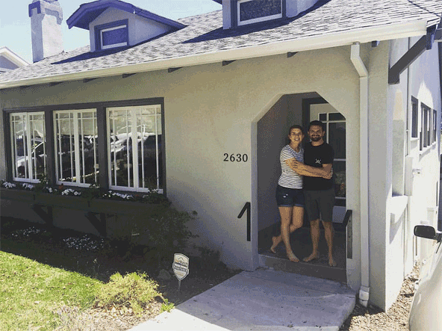
In the “Checklists and Cheat Sheets Section below this video you’ll find a .pdf download which will outline what needs to be done, and gives you step-by-step instructions. They are designed and broken into sections so no part of this project should take more than a weekend to accomplish. This will give you a week-by-week plan of action.

You can download the audio files if you want to listen to this lesson on your iPod, or in your car. The videos are also downloadable.
There’s no problem with copying this and sharing it as much as you want. All I ask is that you don’t chop it up, or change my words. If you’re going to share it, share the entire document or video. If you want to share it on social media, that’s fine too. Spread it far and wide, the more the merrier.
I practice the “80/20” method when it comes to off grid living. That is, I do the things which give me the most bang for my buck, for the least amount of time and expense. I’m looking for the largest return on my time and/or money investment.

There are many more things that can be done. But in my experience doing these 13 things will get the quickest energy savings, least expensively, in the least amount of time. Also feel free to include your own experience or tips in the comments section below. Everyone benefits by sharing knowledge.
.The course is divided up into 13 sections
Chapter1 How to get started quickly and easily
Chapter 2:Your energy budget and why it is important.
Chapter 3: Getting the government and utility companies to help with the cost.
Chapter 4: Updating an older home
Chapter 5: Air sealing part 1
Chapter 6: Air sealing part 2
Chapter 7: Air sealing the basement
Chapter 8: Air sealing the attic
Chapter 10: Save money on lighting:
Chapter 11: Save money on cooking
Chapter 12 Save Money on Laundry
And I have many more parts I’m going to add to this section in the future. When I add to a section, or course, I’ll send an update by email.
OK, that’s it.

